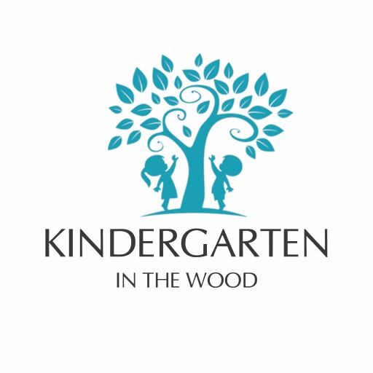
5.9 – Healthy Eating Policy
At Kindergarten in the Wood, we are dedicated to fostering healthy eating habits and ensuring the nutritional well-being of all children in our care. Our Nutrition and Food Policy aligns with the Early Years Foundation Stage (EYFS) welfare requirements, emphasizing the provision of balanced and nutritious meals and snacks.
Policy Aims
- Promote Healthy Choices: Empower children with knowledge and skills to make informed, healthy food and drink selections.
- Provide Balanced Nutrition: Offer meals and snacks that are healthy, balanced, and nutritious, adhering to EYFS guidelines.
- Support Well-being: Ensure all food and drink provisions enhance the health and well-being of children, staff, and visitors.
- Cater to Individual Needs: Provide food that is appropriate to the age and developmental stage of each child, considering any special dietary requirements.
Equal Opportunities
We respect and accommodate the diverse dietary needs of all children, including those arising from religious, cultural, or medical considerations. Our menus are designed to be inclusive, ensuring every child feels valued and included during meal times.
Learning Through Food
We integrate food-related activities into our curriculum to enhance learning and development:
- Practical Engagement: Children participate in preparing snacks, cooking sessions, and food tasting, fostering hands-on learning.
- Gardening Projects: Engaging in planting and growing activities helps children understand the origins of their food.
- Cultural Exploration: Introducing foods from various cultures broadens children's culinary experiences and appreciation for diversity.

Food and Drink Provision
Our daily schedule includes breakfast, morning snack, lunch, afternoon snack, and Supper. Soups and snacks are prepared on-site, focusing on fresh, wholesome ingredients. Menus are regularly reviewed and approved by a qualified dietitian to ensure they meet nutritional standards.
- Drinks: Fresh drinking water is accessible to children at all times. We also offer plain milk during meal and snack times, in line with current food safety guidance.
Special Dietary Requirements
We recognize the importance of catering to individual dietary needs:
- Allergies and Intolerances: Information about any special dietary requirements, preferences, and food allergies is obtained before a child is admitted to the setting. This information is recorded and acted upon to ensure each child's safety and well-being.
- Cultural and Religious Practices: We respect and accommodate dietary rules associated with religious or cultural practices, ensuring all children can participate comfortably in meal times.
Food Safety and Hygiene
Maintaining high standards of food safety and hygiene is paramount:
- Facilities: We provide suitable facilities for the hygienic preparation of food, including appropriate sterilization equipment for infants' bottles .
- Staff Training: All staff involved in preparing and handling food receive training in food hygiene to ensure competence and compliance with safety standards.
- Policies and Procedures: Our food safety management aligns with the "Safer Food, Better Business" guidelines provided by the Food Standards Agency, ensuring robust procedures are in place.
Celebrations and Special Occasions
We acknowledge the significance of special occasions and strive to celebrate them in ways that align with our commitment to healthy eating:
- Birthdays: Celebrations focus on activities and experiences rather than food. If a birthday cake is provided, we ensure it meets our nutritional standards and consider all dietary restrictions.
- Cultural Festivals: We incorporate traditional foods into our menu during cultural celebrations, providing children with diverse and enriching experiences.

Monitoring and Evaluation
We continually assess and refine our Nutrition and Food Policy to ensure its effectiveness:
- Feedback Mechanism: Regular consultations with parents, carers, and staff help us gather feedback and make necessary adjustments to our menus and food-related activities.
- Compliance Checks: Routine inspections and audits ensure adherence to food safety regulations and the maintenance of high hygiene standards.
By implementing this comprehensive Nutrition and Food Policy, Kindergarten in the Wood is committed to promoting the health, well-being, and development of every child through nutritious food choices and positive eating experiences.
In adapting the Nutrition and Food Policy for Kindergarten in the Wood, it's essential to align with the UK's statutory requirements and guidelines for early years settings. These regulations ensure that food provided is healthy, balanced, and nutritious, supporting the well-being and development of young children.
Statutory Requirements and Guidelines:
- Early Years Foundation Stage (EYFS) Framework: The EYFS framework mandates that early years providers must provide healthy, balanced, and nutritious meals, snacks, and drinks. Providers are required to have appropriately equipped areas for the hygienic preparation of food, including suitable sterilization equipment when necessary. It's also essential that staff involved in preparing and handling food receive training in food hygiene to ensure competence.
- Food Standards Agency (FSA) Registration: Early years providers handling food must register with the Food Standards Agency at least 28 days before opening. This registration ensures compliance with food safety standards and is a legal requirement.
- Example Menus and Recipes: The Department for Education, in collaboration with nutrition experts, has published example menus and recipes to assist early years providers in planning healthy and balanced meals. These resources offer practical guidance on portion sizes, food variety, and meal planning to meet children's nutritional needs.
- Food Safety and Hygiene: Providers must ensure that all food safety hazards are identified and controlled. This includes having adequate storage and washing facilities, ensuring food handlers undergo appropriate food safety and hygiene training, and providing suitable equipment and protective clothing. Regular reviews and updates of food safety practices are necessary to maintain high standards.
Policy Adaptations for Kindergarten in the Wood:
- Meal Provision: Soups and snacks will be prepared on the nursery premises, ensuring they are nutritious, balanced, and aligned with current dietary guidelines. Menus will be regularly reviewed and approved by qualified nutritionists or dietitians.
- Staff Training: All staff involved in food preparation and handling will receive accredited food hygiene training. Regular refresher courses will be conducted to maintain high standards of food safety and hygiene.
- Menu Planning: Menus will be planned in advance, offering a variety of foods from different cultures to ensure inclusivity and exposure to diverse tastes. The setting will utilize resources such as the "Example Menus for Early Years Settings in England" to guide meal planning.
- Special Dietary Requirements: The nursery will obtain detailed information from parents regarding any special dietary needs, including allergies, intolerances, and cultural or religious preferences. Individual care plans will be developed and communicated to all relevant staff to ensure these needs are met safely.
- Food Safety Practices: The nursery will implement stringent food safety practices, including regular cleaning of food preparation areas, proper storage of perishable items, and monitoring of food temperatures. Staff will adhere to guidelines set out by the Food Standards Agency and other relevant bodies.
By integrating these statutory requirements and guidelines, Kindergarten in the Wood can provide a safe, healthy, and inclusive food environment that supports the well-being and development of all children in its care.
Name: Mary Da Costa Date : October 2024
Role : Manager Review Date : October 2025

